3. Task – Create Suggestions

1. Suggestion: Add social network icons in the header of the page below the company logo

Steps to reproduce:

* Open the <https://membership.boatiesbestmate.nz/> page
* Check header of the main page
* In the header of the main page, there are no social network icons (like facebook, linkedin, youtube)
* Add icons below the company logo and delete it from footer of the page to get more members and better commercial.

Screenshot:

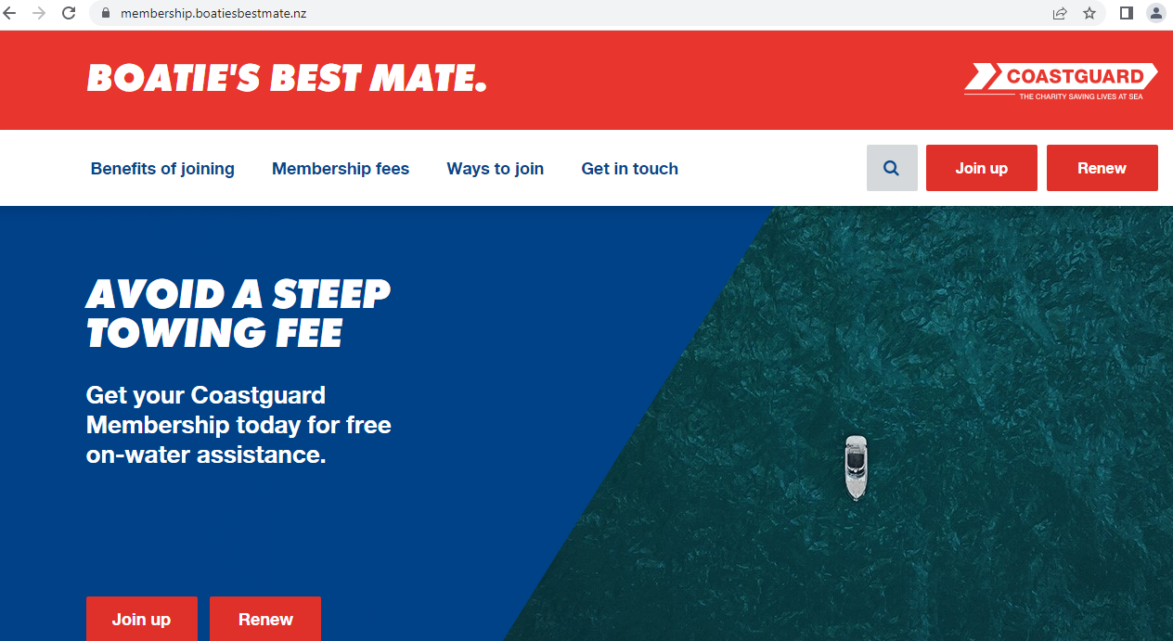

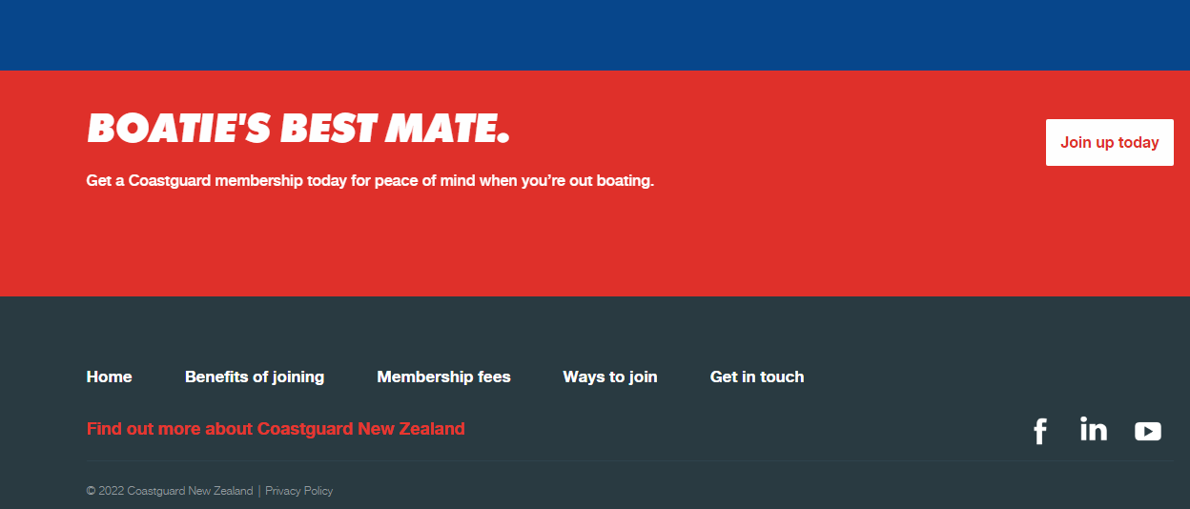

1. Suggestion: Rename Get in touch tab into info

Steps to reproduce:

* Open the <https://membership.boatiesbestmate.nz/> page
* Go to the navigation bar
* Change Get in touch tab into info to make it more understandable for new members and clients.

Screenshot:

